**INSTALLATION TOOLS FOR SAILPOINT IIQ**

Contents

**Identity Management Tools** 4

**Abstract:** 4

**Installation tools for SailPoint IIQ:** 5

**Purpose and usage:** 5

**JDK (Java Development Kit):** 5

**Apache Ant:** 5

**MySQL:** 5

**Tomcat:** 6

**7-Zip:** 6

**Eclipse:** 6

Java Decompiler: 7

**Java Installation** 8

➢ **Download JDK:** 8

➢ **System Requirements:** 9

Installation Steps: 9

Verification: 10

Setting Environmental Variables: 11

Troubleshooting: 12

Apache Ant Installation 13

Download Apache Ant: 13

System Requirements: 14

Installation Steps: 14

Setting Environmental Variables: 15

Verification: 17

Troubleshooting: 18

MySQL Installation 18

Download MySQL: 18

System Requirements: 19

Installation Steps: 20

Setting Environmental Variables: 29

Verification: 31

Troubleshooting: 32

Apache Tomcat installation 33

Download Apache Tomcat: 33

Extract the Tomcat Archive: 34

Set Environment Variables: 34

Start Tomcat: 35

Access the Tomcat Manager: 38

Stop Tomcat: 39

Deploy Web Applications: 39

7 zip installation 43

Download 7-Zip: 43

Select the Version: 43

Download the Installer: 44

Run the Installer: 44

Choose Installation Options: 45

Select Install Location: 45

Install: 45

Finish Installation: 46

Eclipse installation 47

Download Eclipse: 47

Select Mirror and Download: 48

Run Eclipse: 49

Select Workspace: 49

Complete the Setup: 50

Java Decompiler Installation 51

Download JD-GUI: 51

# **Identity Management Tools**

## **Abstract:**

In identity management, robust tools are paramount for ensuring secure and efficient governance of user identities. This abstract delves into the crucial aspects of installing tools specific to SailPoint Identity Now, previously known as SailPoint IIQ (Identity IQ). The installation process involves strategic configurations of databases, application servers, and Java environments, collectively laying the foundation for comprehensive identity management.

# **Installation tools for SailPoint IIQ:**

## **Purpose and usage:**

### **JDK (Java Development Kit):**

* **Purpose:**
  + SailPoint Identity Now is a Java-based application, and the JDK is essential for compiling and running Java code.
* **Usage:**
  + JDK is required to run SailPoint Identity Now as it is built on Java technologies.

### **Apache Ant:**

* **Purpose:**
  + Ant is a build tool used for automating the build and deployment processes.
* **Usage:**
  + SailPoint may use Ant scripts for tasks like building custom connectors, deployment, or other automation processes.

### **MySQL:**

* **Purpose:**
  + MySQL is a relational database management system (RDBMS) that can be used as a backend database for SailPoint Identity Now.
* **Usage:**
  + SailPoint Identity Now stores configuration and operational data in a relational database, and MySQL can be configured to serve this purpose.

### **Tomcat:**

* **Purpose:**
  + Tomcat is a popular application server that can be used to host and deploy Java-based web applications.
* **Usage:**
  + SailPoint Identity Now can be deployed on Tomcat as its application server. Tomcat serves as the runtime environment for the Identity Now application.

### **7-Zip:**

* **Purpose:**
  + 7-Zip is a file compression and decompression tool.
* **Usage:**
  + It might be used during the installation or configuration process to extract compressed files or archives related to SailPoint Identity Now or its dependencies.

### **Eclipse:**

* **Purpose:**
  + Eclipse is an integrated development environment (IDE) that supports Java development.
* **Usage:**
  + Developers working on customizations, extensions, or integrations with SailPoint Identity Now may use Eclipse for coding, debugging, and testing.

### **Java Decompiler:**

* **Purpose:**
  + A Java Decompiler is used to reverse engineer compiled Java bytecode back into human-readable Java source code.
* **Usage:**
  + In development or troubleshooting scenarios, a Java Decompiler might be used to analyze and understand the code, especially when dealing with customizations or extensions.

# 

# **Java Installation**

## **Download JDK:**

* Visit the official Java SE downloads page: Java SE Downloads.
* Choose the appropriate JDK version (java SE Development kit 11.0.19) for your operating system (Windows, Linux, macOS).
* Follow the instructions to download and run the installer.

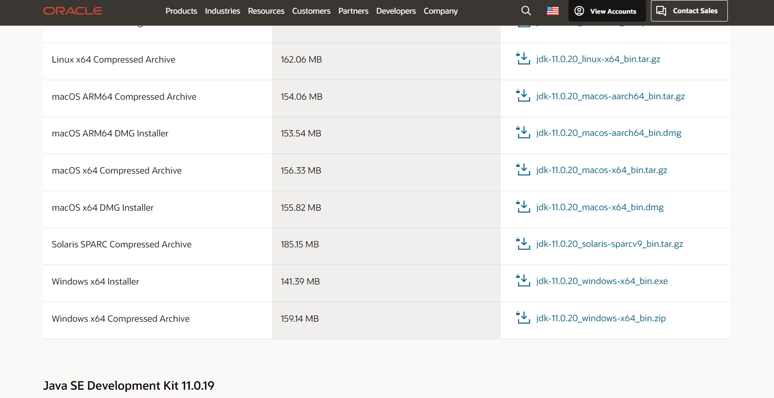

### **System Requirements:**

* Refer to the system requirements section on the download page.
* Ensure your system meets the minimum requirements for the selected JDK version.

### **Installation Steps:**

* Double-click the downloaded executable file.
* Follow the installation wizard, selecting default options or customizing as needed.
* Check the java file in program files located inside local disk (c).

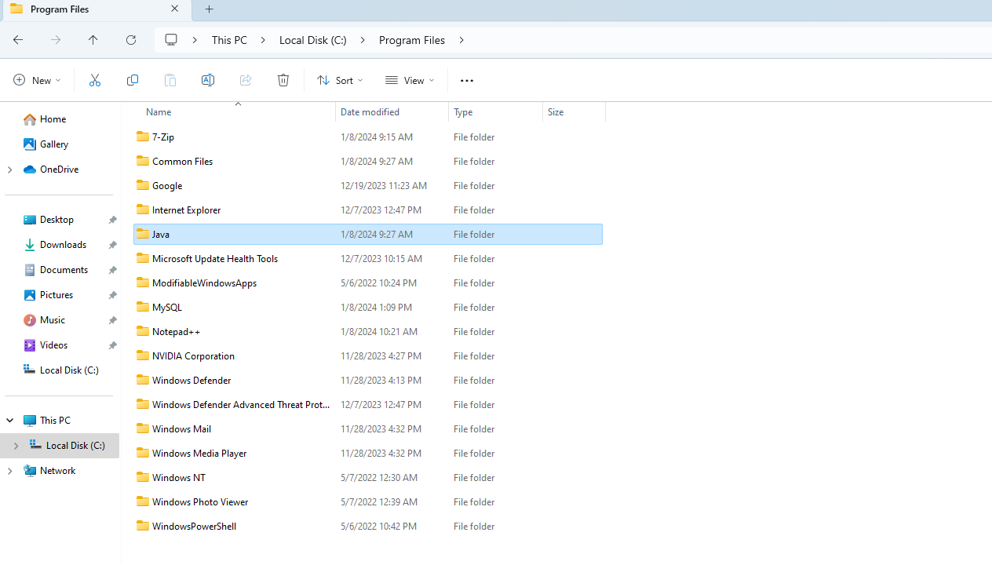

### **Verification:**

* Open a terminal or command prompt.
* Type **java -version** to check the installed Java version.

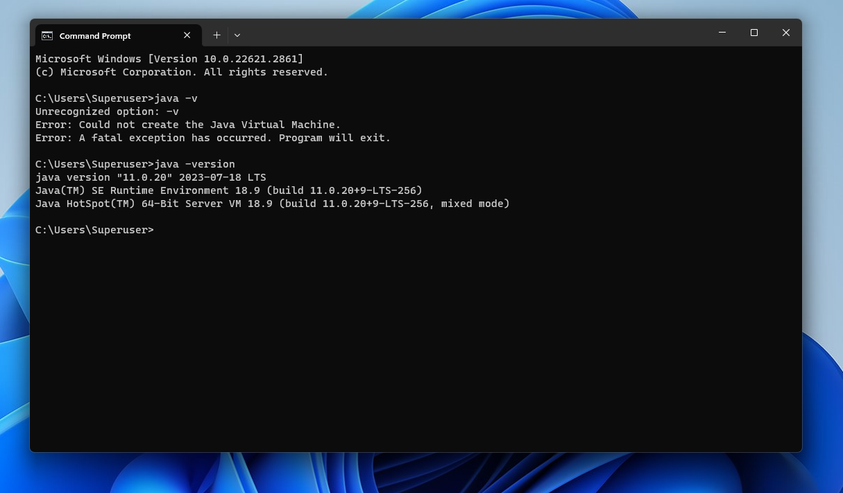

### **Setting Environmental Variables:**

* **JAVA_HOME Variable:**

1. For Windows:
2. Open System properties.
3. Click on “Environment variables”.
4. Add a new system variable named **JAVA_HOME** with the value being the path to your JDK installation.
5. C:\Program Files\Java\jdk-11

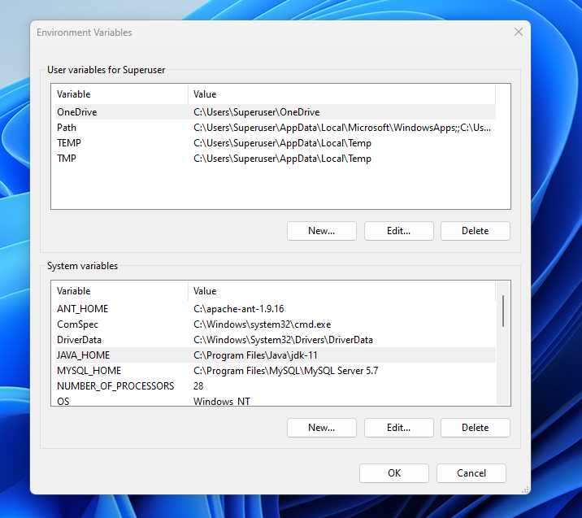

* **PATH Variable:**

1. For Windows:
2. Browse and add the JDK's **bin** directory to the end of the **Path** variable.
3. C:\Program Files\Java\jdk-11\bin

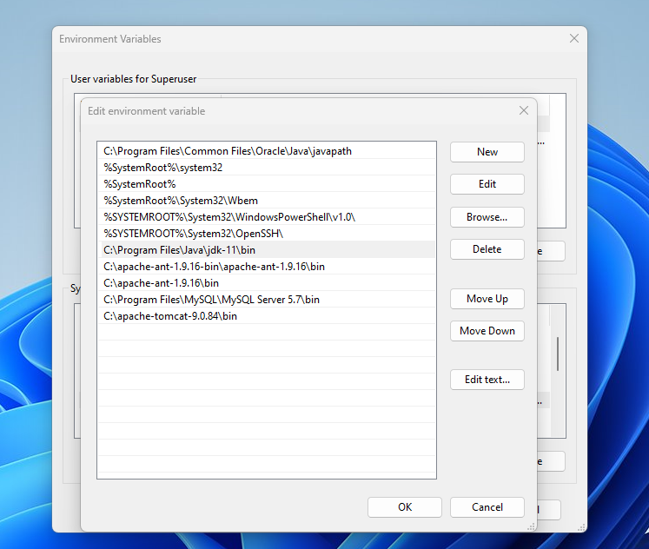

### **Troubleshooting:**

* Check for common issues during installation and configuration.
* Refer to online forums or communities for assistance.

# **Apache Ant Installation**

## **Download Apache Ant:**

* Visit the official Apache Ant website: Apache Ant - Download.
* Choose the desired version and download the binary distribution (ZIP or TAR.GZ).

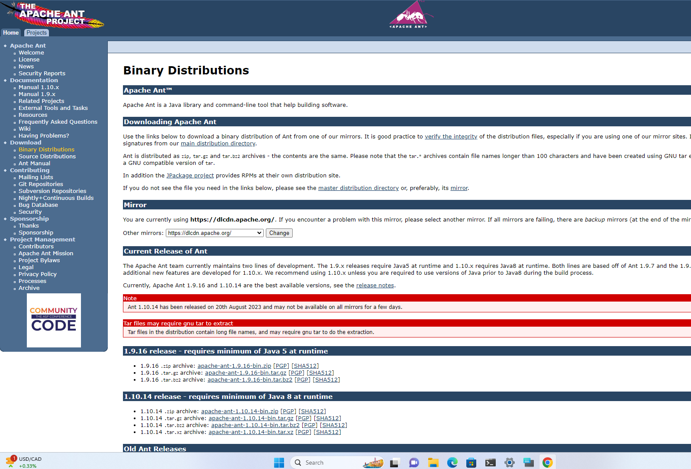

### **System Requirements:**

* Refer to the system requirements specified on the Apache Ant download page.
* Ensure your system meets the prerequisites, including Java being installed.

### **Installation Steps:**

* Extract the downloaded archive to a directory of your choice.
  + **For Windows:**
    - Use a tool like WinZip or 7-Zip to extract the contents.
    - Copy the extracted file into the local C drive and paste it there, and make sure to keep only single file not multiple.

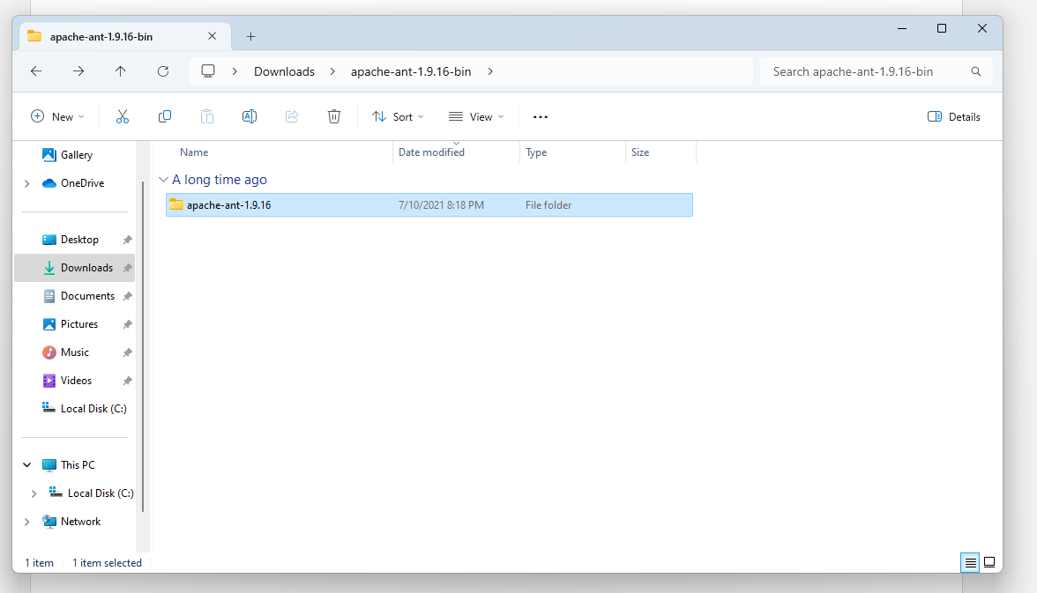

### **Setting Environmental Variables:**

* **ANT_HOME Variable:**
* Set the **ANT_HOME** variable to the directory where Apache Ant is installed.
* For Windows:
* Open System properties.
* Click on “Environment variables”.
* Add a new system variable named **ANT_HOME** with the value being the path to your JDK installation.
* C:\apache-ant-1.9.16

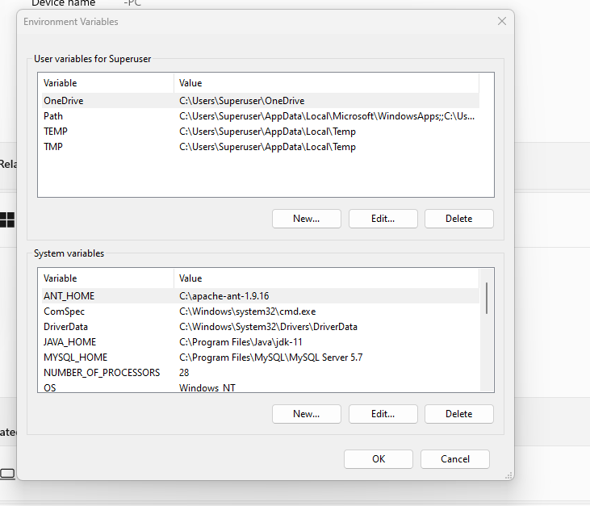

* **PATH Variable:**
* Browse and add the **bin** directory inside the Apache Ant installation to the system's **PATH**.
* C:\apache-ant-1.9.16\bin

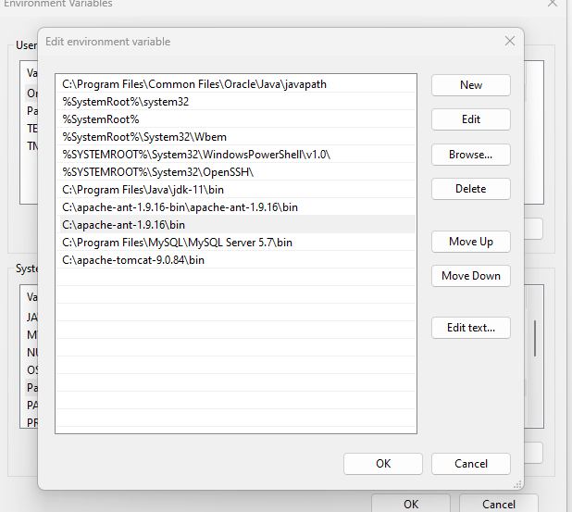

### **Verification:**

* Open a new terminal or command prompt.
* Type **ant -version** to verify the successful installation.

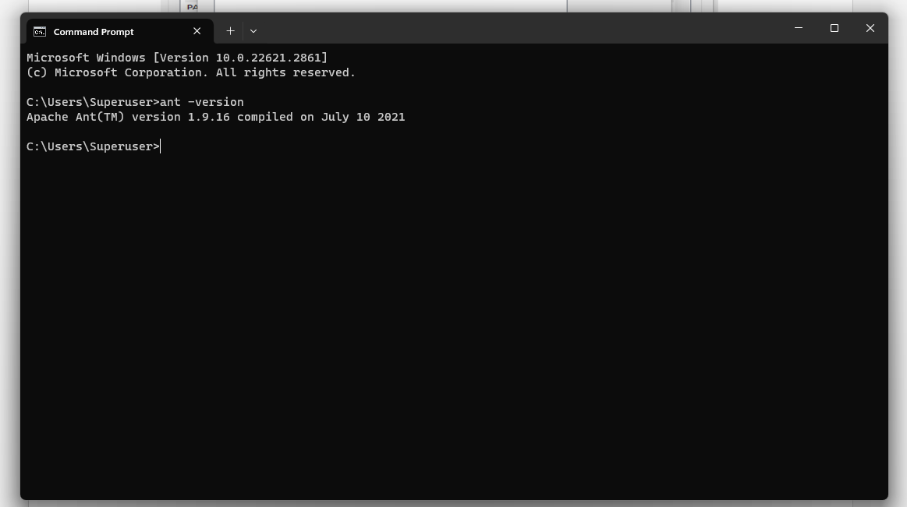

### **Troubleshooting:**

* Include common issues and solutions related to Apache Ant installation.

# 

# **MySQL Installation**

## **Download MySQL:**

* Visit the official MySQL website: MySQL Downloads.
* Choose the MySQL edition that suits your needs (MySQL Community Server, MySQL Enterprise, etc.).
* Select the appropriate version for your operating system (Windows, Linux, macOS).

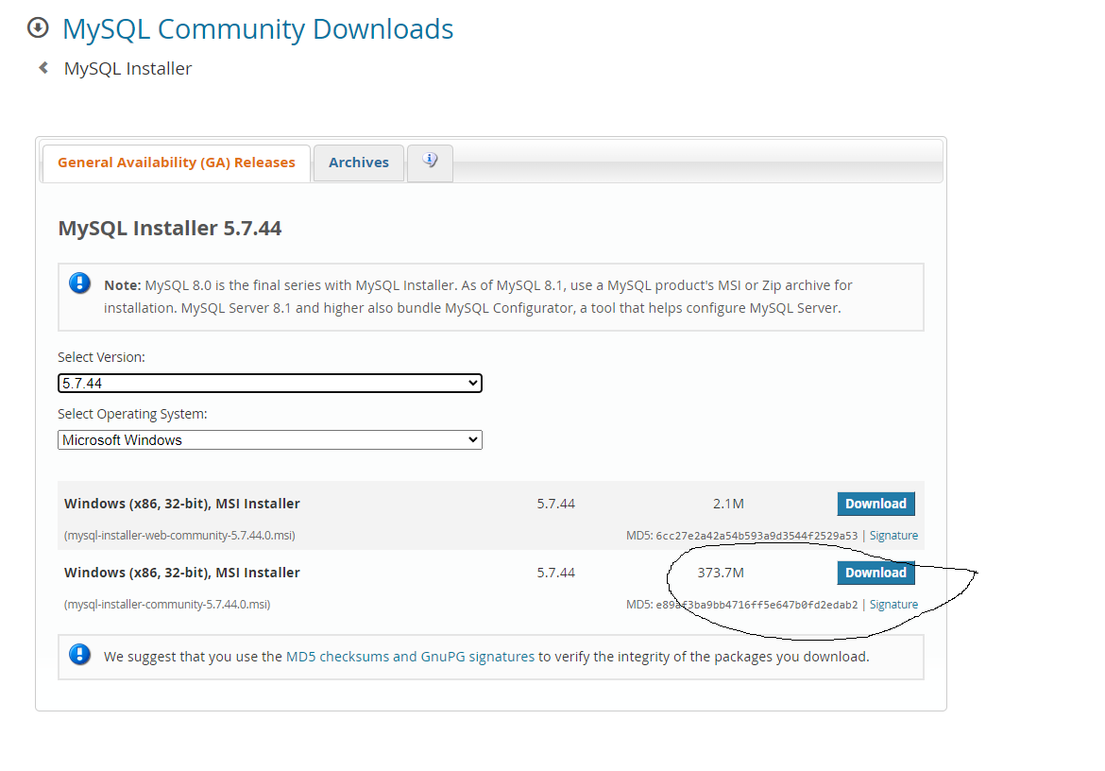

### **System Requirements:**

* Review the system requirements provided on the MySQL download page.
* Ensure your system meets the prerequisites, including any required libraries or dependencies.

### **Installation Steps:**

#### **Step1:**

* After downloading the setup, unzip it anywhere and double click the MSI **installer .exe file.** It will give the following screen:

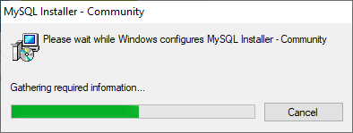

#### **Step2:**

* Choose a Setup Type - Developer Default, Server only, Client only, Full, Custom, I choose Server only.

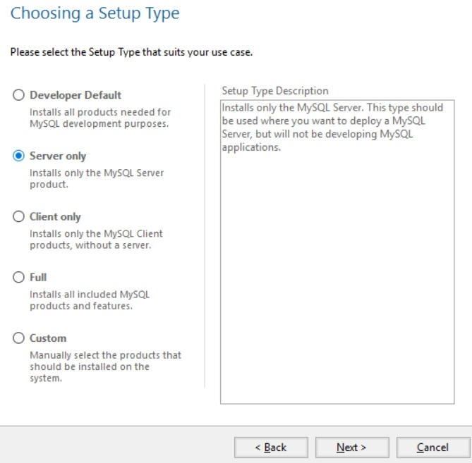

#### **Step3:**

* **Download components**
* Example MySQL Server 8.0.15 is ready to be downloaded.

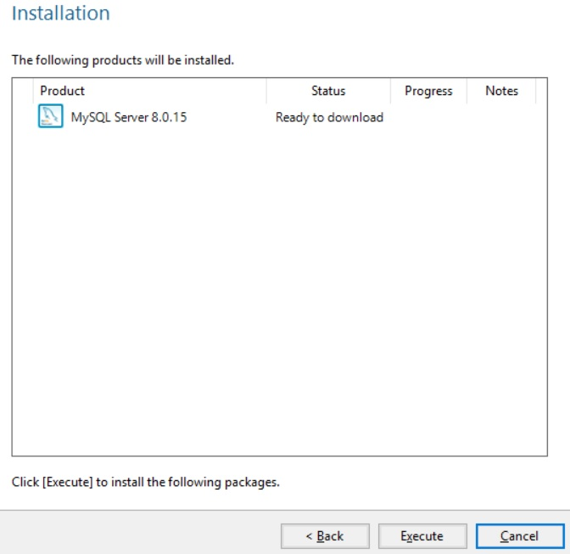

#### **Step4:**

* **Configuration**

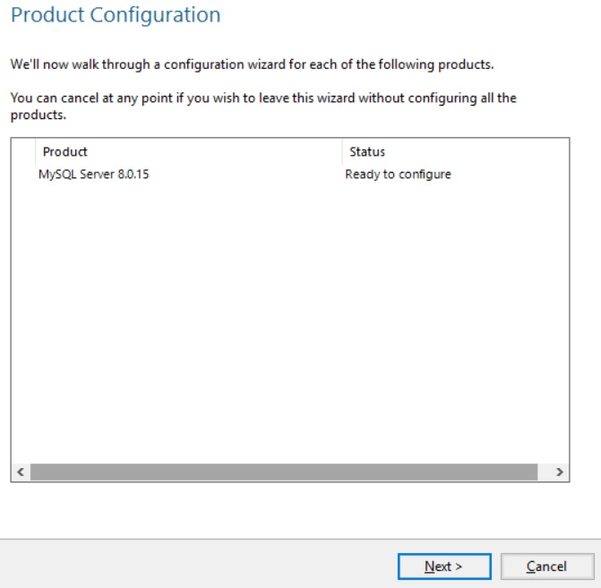

#### **Step5:**

* **Group Replication**

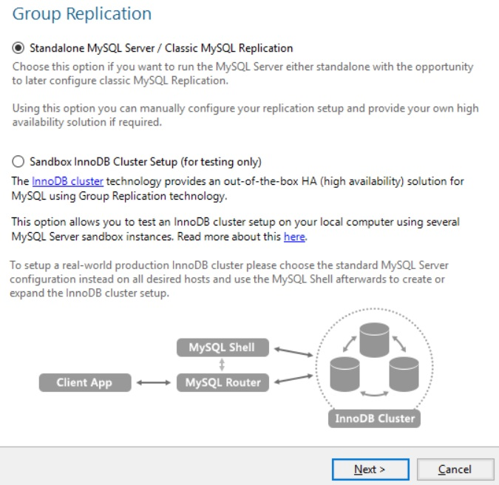

#### **Step6:**

* **Networking –** The default port for MySQL is 3306.

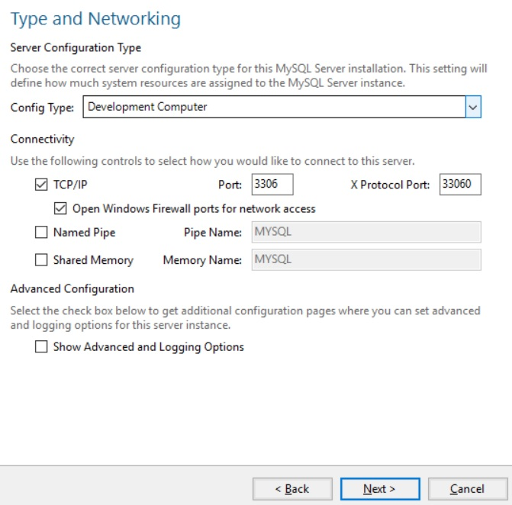

#### **Step7:**

* **Authentication**
* Accept the default values and continue to next.

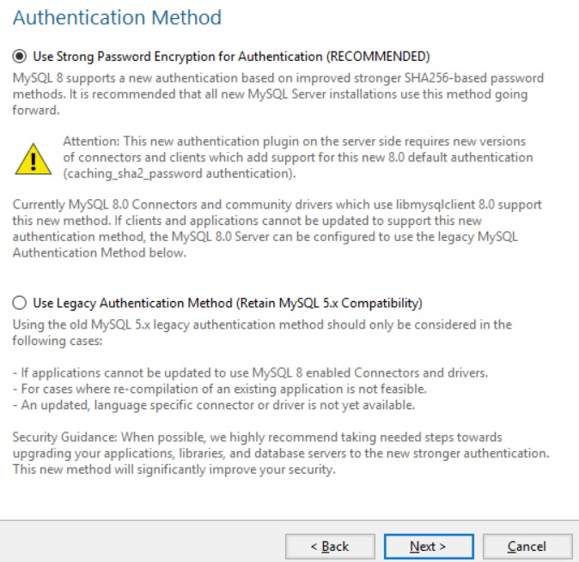

#### **Step8:**

* **Accounts and Roles**
* Creating Root account password. Example password: Admin@123

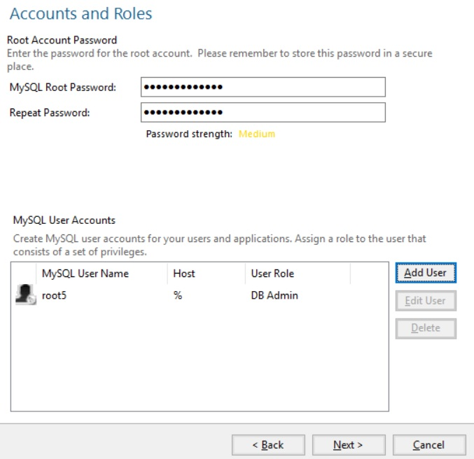

#### **Step9:**

* **Apply configuration**

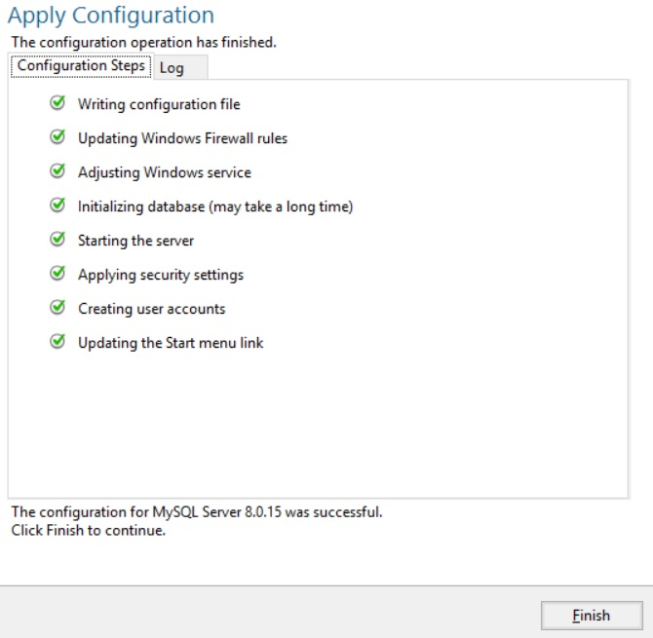

* Click Finish
* Go to the program files folder inside there will be MySQL folder.

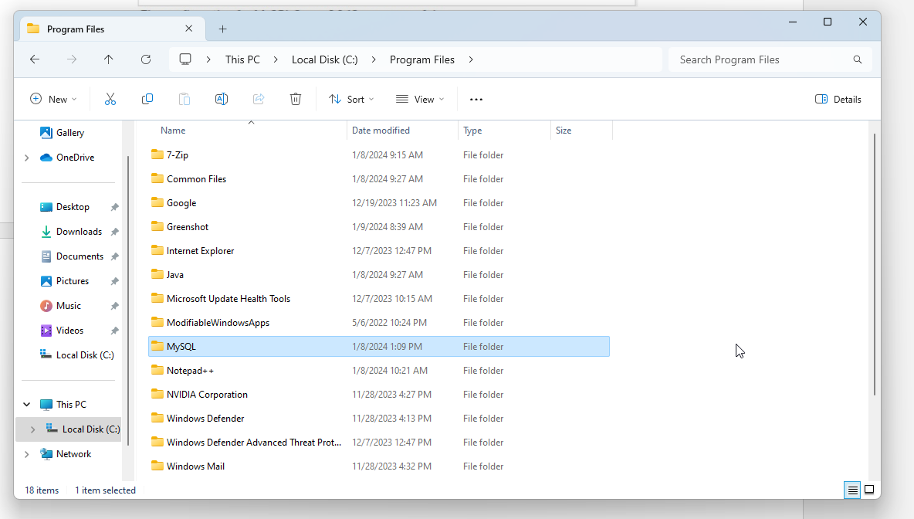

### 

### **Setting Environmental Variables:**

* **MYSQL_HOME Variable:**
* Set the **MYSQL_HOME** variable to the directory where Apache Ant is installed.
* For Windows:
* Open System properties.
* Click on “Environment variables”.
* Add a new system variable named **MYSQL**_**HOME** with the value being the path to your JDK installation.
* C:\Program Files\MySQL\MySQL Server 5.7

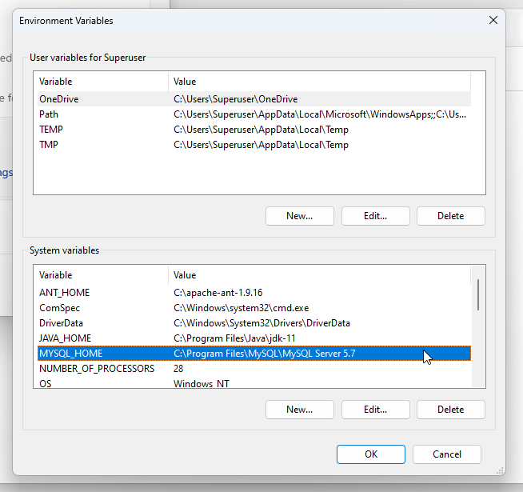

* **PATH Variable:**
* Browse and add the **bin** directory inside the Apache Ant installation to the system's **PATH**.
* C:\Program Files\MySQL\MySQL Server 5.7\bin

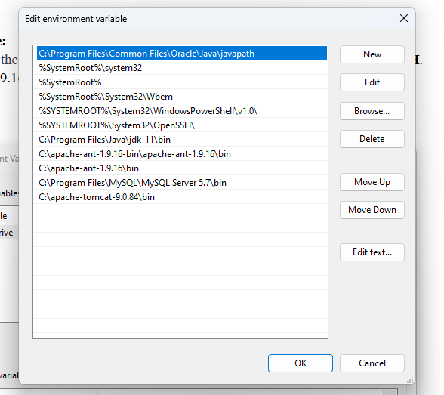

### **Verification:**

* Open a new terminal or command prompt.
* Type MySQL –u root -p to verify the successful installation.

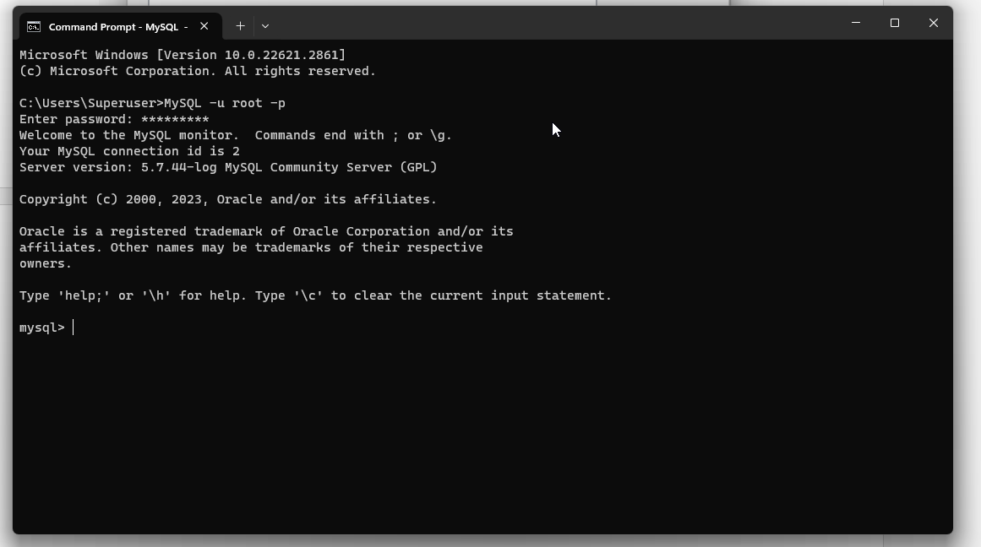

### **Troubleshooting:**

* Check for common issues during installation and configuration.
* Refer to online forums or communities for assistance.

**Apache Tomcat installation**

## **Download Apache Tomcat:**

* Visit the Apache Tomcat official website.
* Navigate to the "Download" section and choose the version of Tomcat that suits your requirements. Select the Core distribution (ZIP or TAR.GZ format) for manual installation.

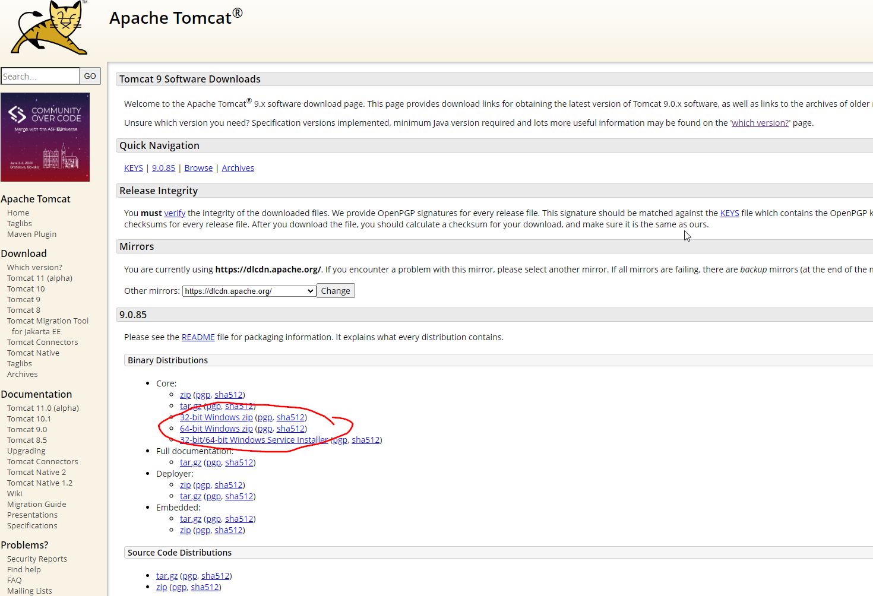

### **Extract the Tomcat Archive:**

* Once the download is complete, extract the archive's contents to a directory of your choice.
* For example, if you have downloaded a ZIP file, you can extract it using a tool like 7-Zip or the built-in extraction tool in your operating system.
* Copy and paste the extracted file in the local C file, make sure to paste single file not multiple.

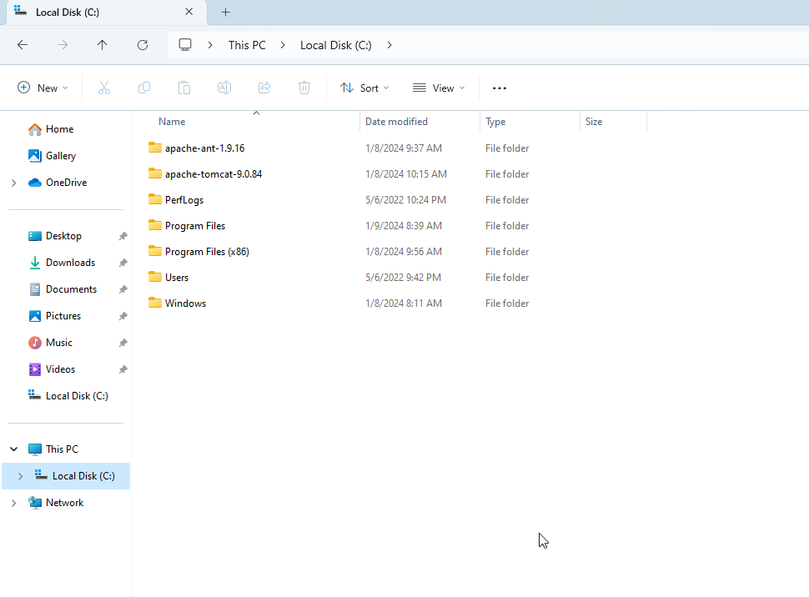

### **Set Environment Variables:**

* Set the **CATALINA_HOME** environment variable to point to the Tomcat installation directory.
* Optionally, you may set the **CATALINA_BASE** variable to a specific instance directory if you plan to run multiple Tomcat instances.

### **Start Tomcat:**

* Open a command prompt or terminal window.
* Navigate to the "bin" directory within the Tomcat installation.
* Run the startup script:
  + On Windows: Execute **startup.bat**.

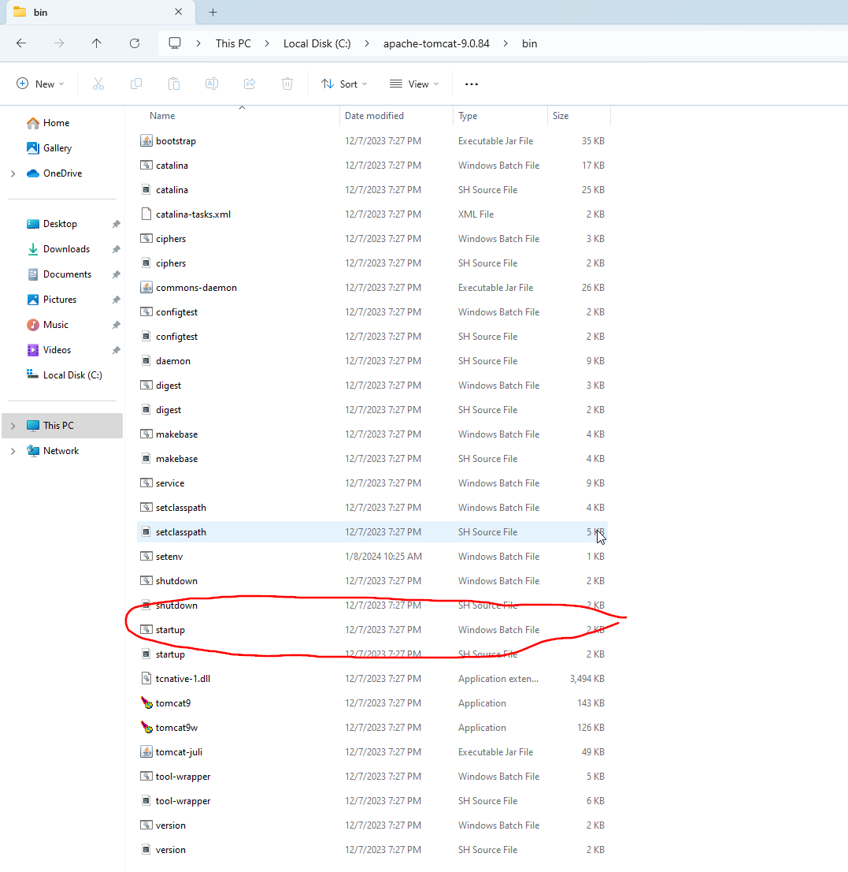

* Double click on startup.bat.

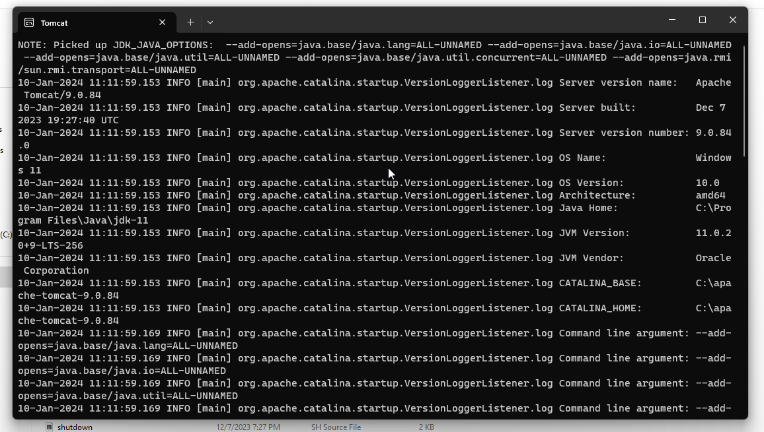

### **Access the Tomcat Manager:**

* Open a web browser and go to **http://localhost:8080** (assuming the default port is used).
* If Tomcat has been successfully started, you should see the Tomcat welcome page.

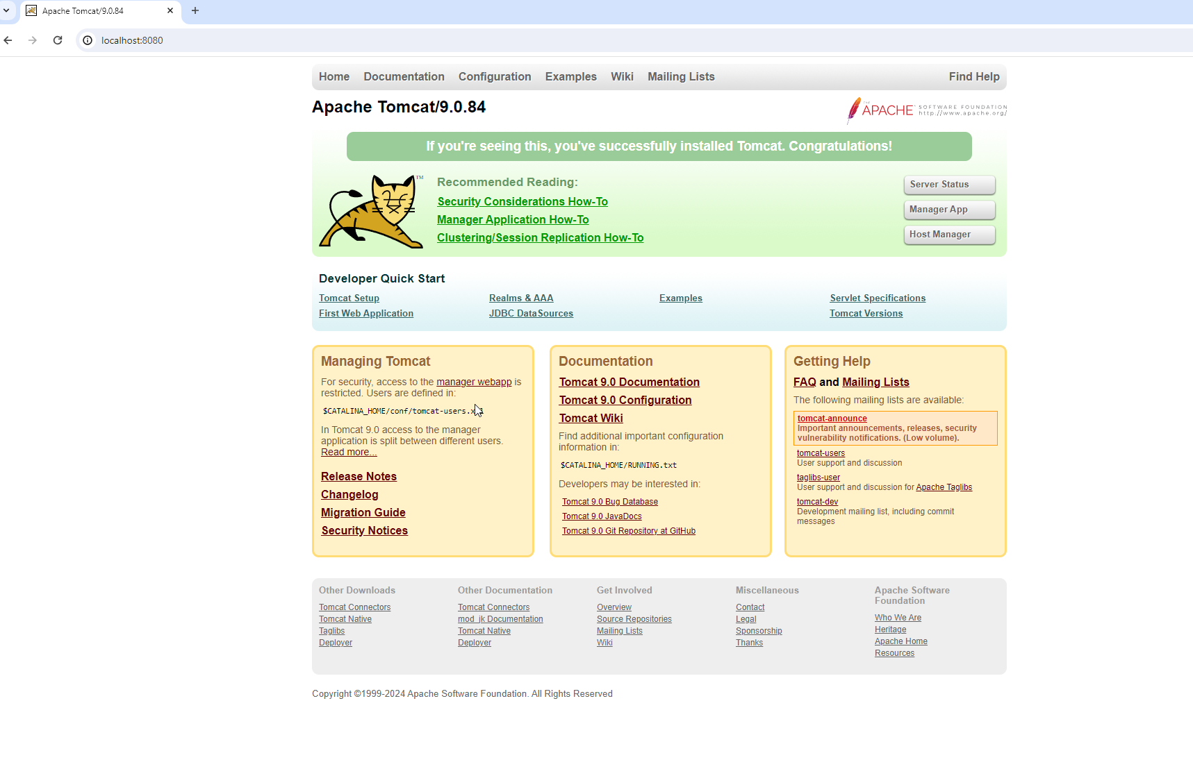

### **Stop Tomcat:**

* To stop Tomcat, you can use the shutdown script: double click on
  + On Windows: Execute **shutdown.bat**.

### **Deploy Web Applications:**

* To deploy web applications, copy your **.war** files to the **webapps** directory within the Tomcat installation.
* Create a .war File: First, ensure that you have a web application packaged as a **.war** file. If you don't have one, you can use a simple example or create one using tools like Apache Maven or manually by organizing your web application files and compressing them into a **.war** archive. Take a sample. War file.

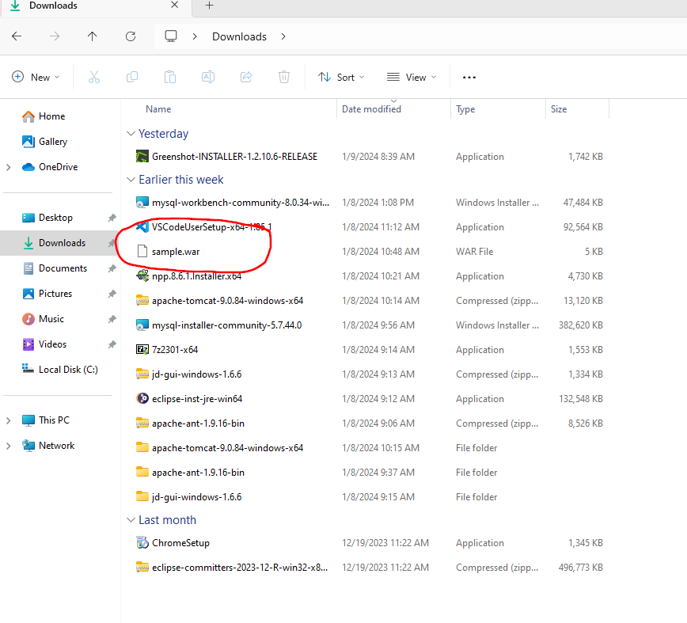

* **Create a .war File:** Place the **.war** file into the **webapps** directory within your Tomcat installation.
* This directory is typically located in the Tomcat installation directory: “C:\apache-tomcat-9.0.84\webapps”.
* **Automatic Deployment:** Tomcat is configured by default to automatically deploy applications placed in the **webapps** directory. Upon copying the **.war** file, Tomcat will automatically extract and deploy the application.
* If Tomcat is running, it will detect the presence of the new **.war** file and deploy the web application.
* The following sample .war file is automatically extracted.

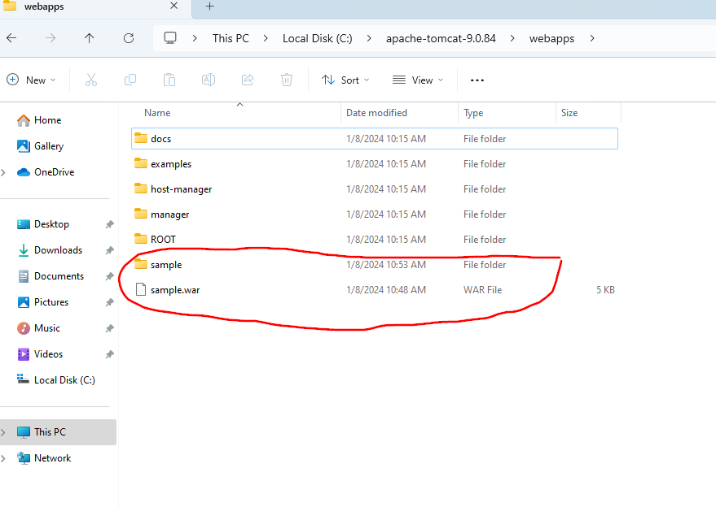

* **Access the Deployed Application:** Once the application is deployed, you can access it through your web browser. The URL typically follows the format: http://localhost:8080/sample/
* The tomcat is in start state, when the web browser is accessed.

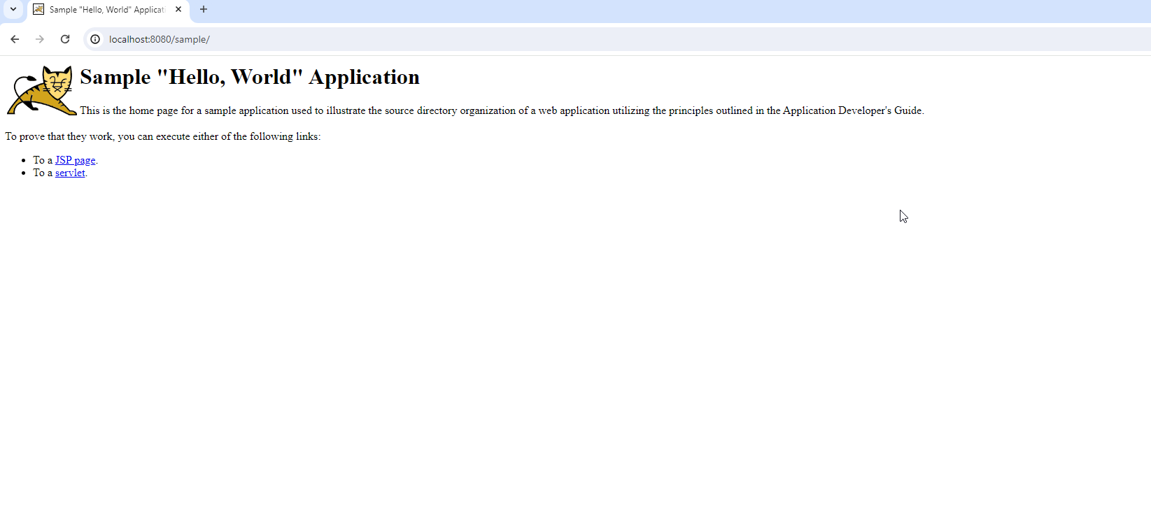

# **7 zip installation**

## **Download 7-Zip:**

* Visit the official 7-Zip website: <https://www.7-zip.org/>
* Navigate to the "Download" section.

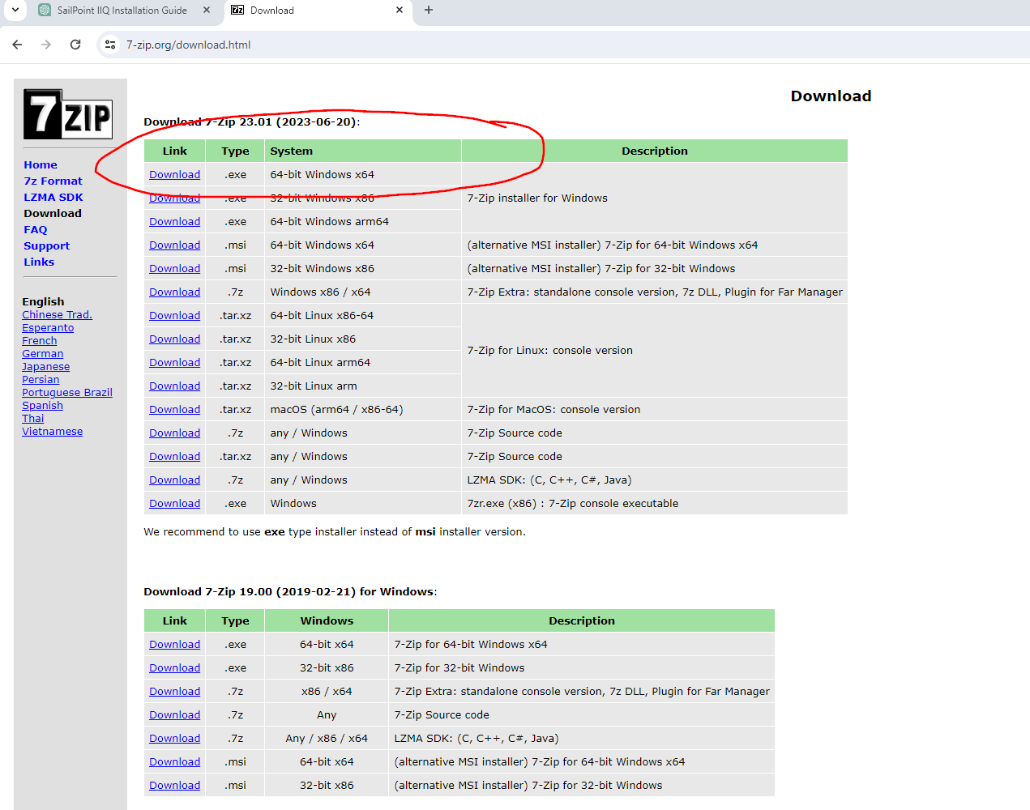

### **Select the Version:**

* Choose the version that corresponds to your operating system (32-bit or 64-bit). Most modern systems use the 64-bit version.

### **Download the Installer:**

* Click on the download link to download the 7-Zip installer. The installer is usually an executable (.exe) file.

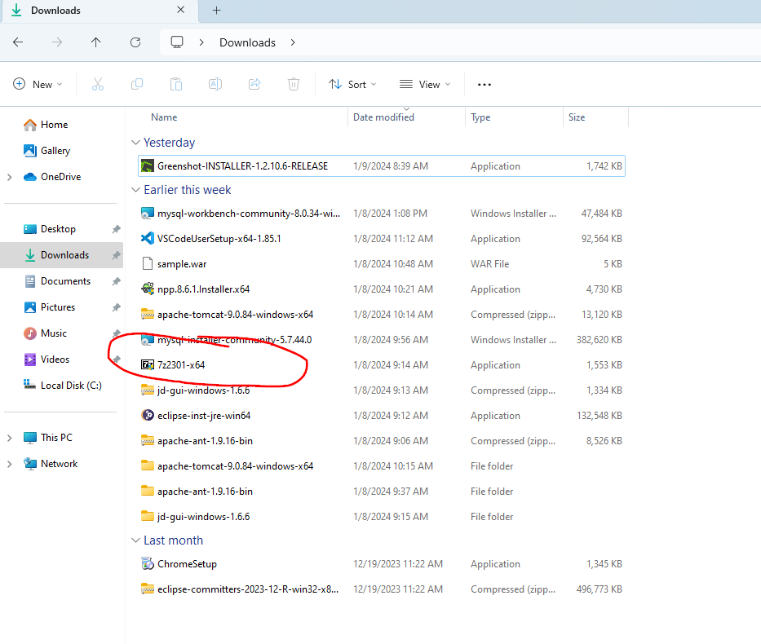

### **Run the Installer:**

* Once the download is complete, locate the downloaded installer file (e.g., **7z****.exe** where **\*\*\*\*** corresponds to the version number).
* Double-click on the installer file to run it. If you see a User Account Control (UAC) prompt, click "Yes" to allow the installer to make changes to your system.

### **Choose Installation Options:**

* The installer will open a setup window. Here, you can choose the installation options. The default options are usually suitable for most users.
* You may choose to associate file types with 7-Zip if you want to use it as the default program for handling compressed files.

### **Select Install Location:**

* Choose the destination folder where 7-Zip will be installed. The default location is typically in the "Program Files" directory.

### **Install:**

* Click the "Install" button to begin the installation process. The installer will extract and copy the necessary files to your system.

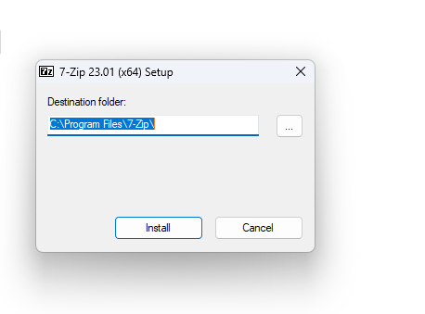

### **Finish Installation:**

* Once the installation is complete, click the "Finish" button.

# **Eclipse installation**

## **Download Eclipse:**

* Visit the official Eclipse download page: https://www.eclipse.org/downloads/
* Choose the Eclipse IDE package that best suits your needs. There are different packages tailored for various development environments, such as Java, C++, PHP, and more. For Java development, you might choose "Eclipse IDE for Java Developers."
* Click on the download link corresponding to your operating system (Windows, macOS, or Linux).

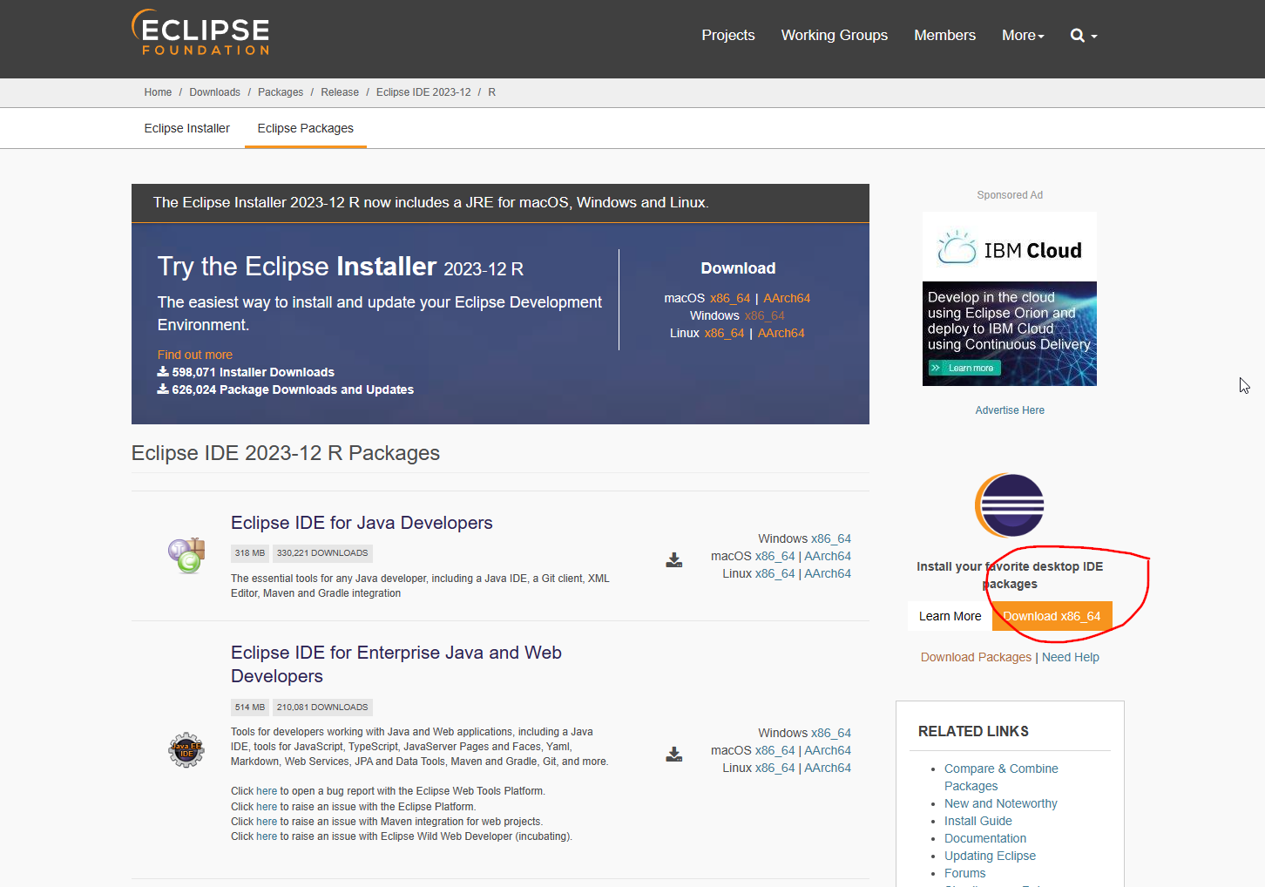

### **Select Mirror and Download:**

* You will be redirected to a list of mirrors. Choose a mirror site near your location and click on the download link.

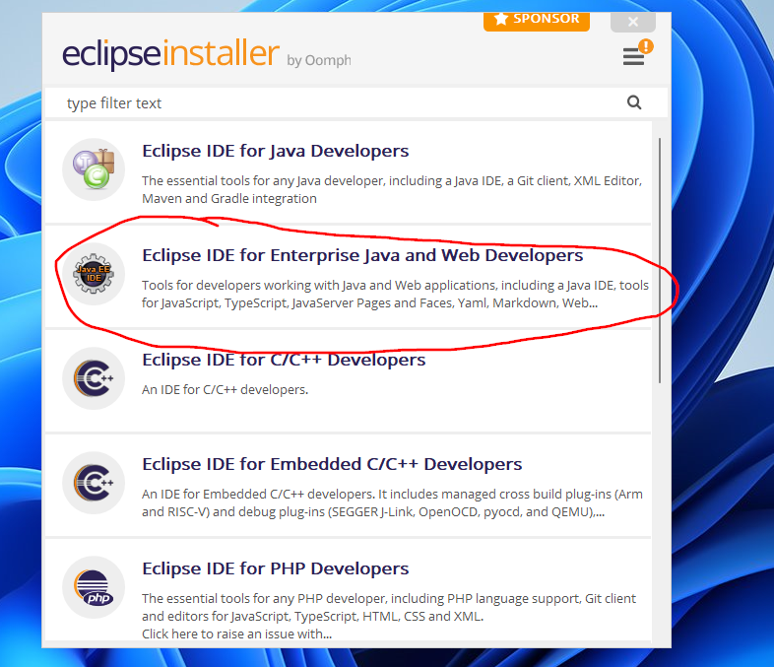

### **Run Eclipse:**

* Navigate to the directory where you extracted Eclipse.
* Look for the Eclipse executable file (e.g., **eclipse.exe** on Windows, **eclipse** on Linux/macOS), and double-click to run it.

### **Select Workspace:**

* On the first launch, Eclipse will ask you to select a workspace. The workspace is the directory where your projects will be stored. You can use the default or choose a different location.

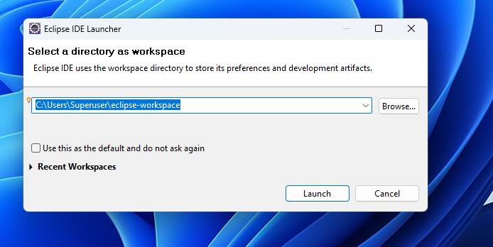

### **Complete the Setup:**

* Eclipse may prompt you to complete the setup, which may include selecting a theme and configuring other preferences. Follow the on-screen instructions to finish the setup.

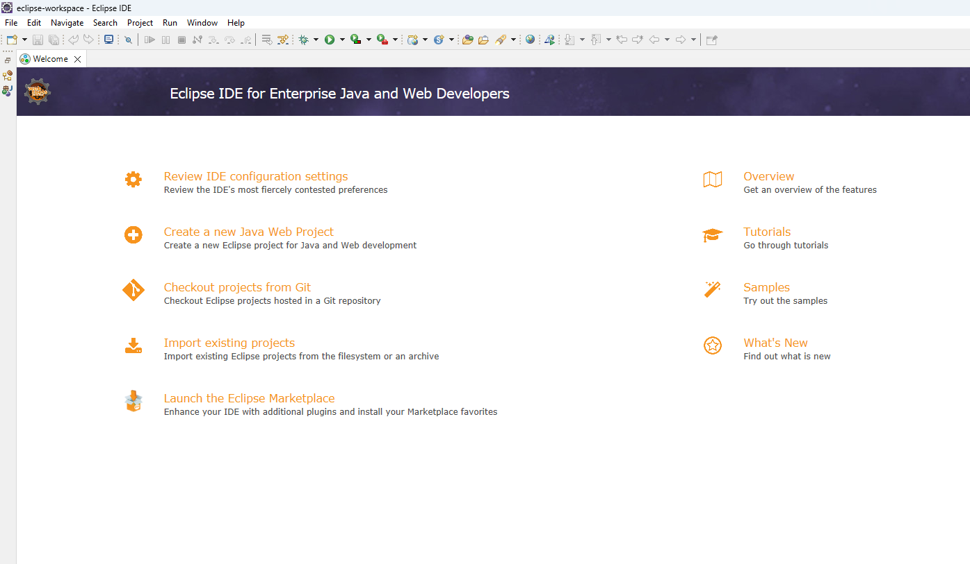

# **Java Decompiler Installation**

## **Download JD-GUI:**

* Visit the official JD-GUI website: http://java-decompiler.github.io
* Look for the download section and choose the appropriate version for your operating system (Windows, macOS, or Linux).

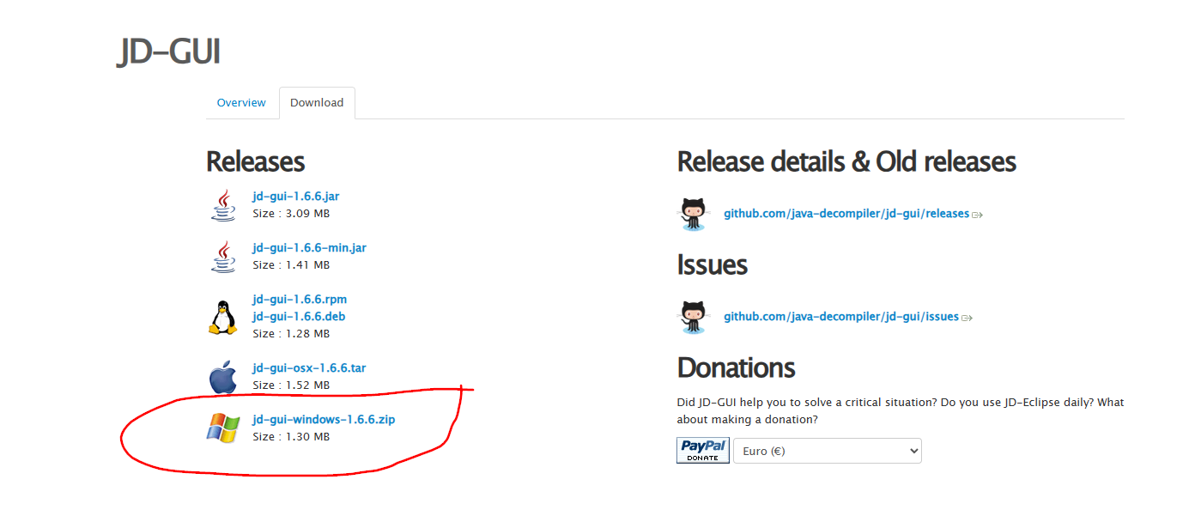

* If you downloaded a zip file, extract its contents to a location on your computer.
* If you downloaded an installer (such as a .exe file on Windows or a .dmg file on macOS), run the installer and follow the on-screen instructions.

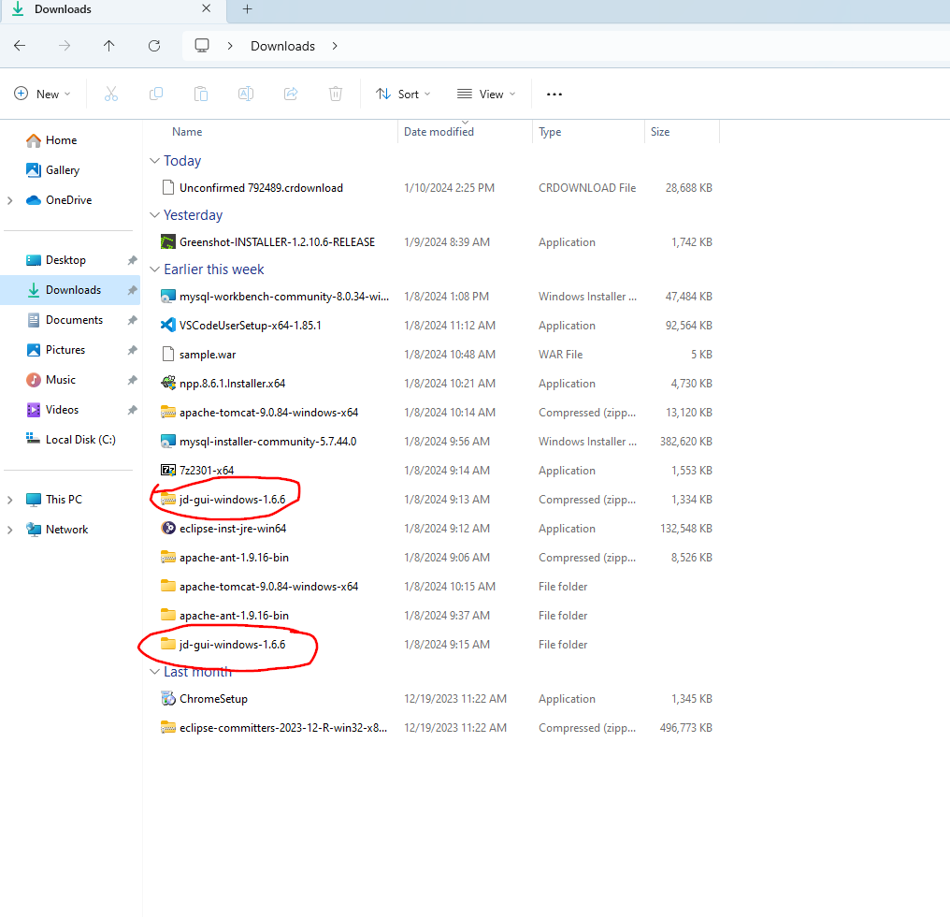

**LINKS TO DOWNLOAD THE TOOLS AND VERSIONS:**

**JDK:** <https://www.oracle.com/java/technologies/javase/jdk11-archive-downloads.html>

Version: Java SE Development Kit 11.0.20.

**Apache Ant:** <https://ant.apache.org/bindownload.cgi>

Version: Advanced

**MySQL:** [**https://dev.mysql.com/downloads/windows/installer/5.7.html**](https://dev.mysql.com/downloads/windows/installer/5.7.html)

Version: MySQL Installer 5.7.44

**Apache Tomcat:** <https://tomcat.apache.org/>

Version: Tomcat 9.0.85

**7-zip:** <https://www.7-zip.org/download.html>

**Eclipse:** [**https://www.eclipse.org/downloads/packages/**](https://www.eclipse.org/downloads/packages/)

**Java Decompiler:** [**https://java-decompiler.github.io/**](https://java-decompiler.github.io/)